All Rates include: A Chef prepared Hearty Breakfast served daily from 7-10am. Complimentary Afternoon Snacks.
Pet Fees $35.00 per day. It’s a 2-story building with no elevator.
All rates are per person double occupancy. Limited availability of some rooms.

DELUXE QUEEN & DOUBLE BEDROOM $370.
4 NO SMOKING FULL BATHROOM PETS MICROWAVE MINI-FRIDGE WIFI HOT TUB ACCESS SAUNA (SHARED) A/C
Access to this unit may involve stairs.
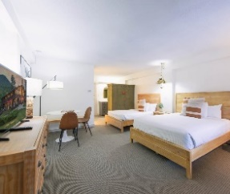

JUNIOR SUITE - 1 QUEEN & 2 DOUBLE BEDS with 3 persons to a suite $310. This is a 2 room suite
6 NO SMOKING FULL BATHROOM PETS MICROWAVE MINI-FRIDGE WIFI HOT TUB ACCESS POOL ACCESS HILLSIDE VIEW PARK VIEW GARDEN VIEW SAUNA (SHARED) A/C
